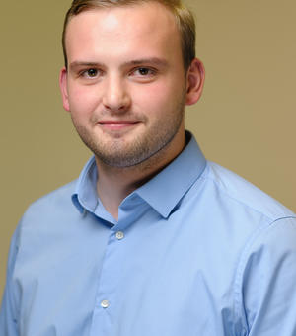

Do You Have OCD (Obsessive Compulsive Disorder)?

We are interested to learn more from you about how your difficult interpersonal memories impact on your emotions in the present.

We are looking for volunteers aged 18 years and over. Participating in the research will take approximately 1 hour, and will involve a short telephone discussion, an experimental task via video, and completion of some questionnaires.

Can you help us? Please contact us to find out more:
sam.french@hmc.ox.ac.uk
Oxford Institute of Clinical Psychology Training & Research

